SPARK: Simple Play Adaptations to Reference for Kids

QuickTalker FeatherTouch 12
Description: | Image:
The QuickTalker FeatherTouch 12 is a multi-celled, multi-leveled message static display augmentative and alternative communication (AAC) speech device that can assist children who need speech support throughout their daily activities. It Includes three core messages that are the same on every recording level and 48 unique messages available across five recording levels. When the cell is activated a spoken message is played. The 3 core message surfaces (cells) are - 2.2 x 1.2-in; the 9 unique message surfaces are 2.2 x 1.7-in. The QuickTalker FeatherTouch 12 is highly portable with a built-in handle, durable, and easy to use. The weight of the device with 4 AA batteries is 26.4 ounces. | 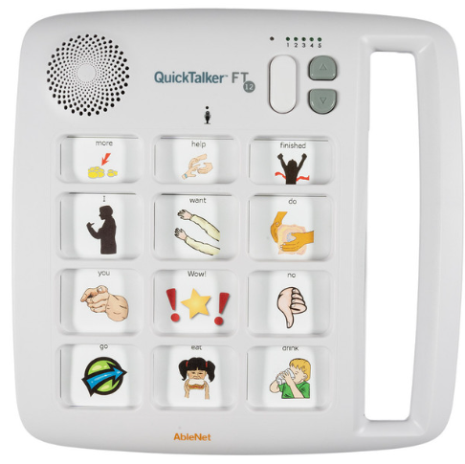  Purchasing Information  QuickTalker FT 7, 12, 23 Quick Start Guide  Video

Who Might Benefit?
Those who…
• Are difficult to understand or have unreliable speech.
• Have difficulty expressing ideas, feelings, needs, wants.
• Exhibit frustration or anger because others are unable to understand their communication attempts.
• Struggle socially with peers because of communication difficulties.
• Have difficulty understanding only oral directions given by others.
• Have difficulty understanding and completing multi-step activities (schedules, routines, directions).
• Have adequate fine motor skills to isolate a finger to poke the communication cell or press a switch to activate the device. This skill is specific to this device, however there are many different access methods that can be used with other communication devices if needed.
Why Use?
Provides an opportunity to…
• Make choices.
• Comment more effectively to others.
• Engage in multiple shared communication exchanges.
• Hear verbal directions paired with a visual cue as many times as needed.
Instructions for Use: | Adaptation Ideas:
Environmental Considerations  - Easily use in almost any environment because of the small size, weight, and easy transportability.  - May be difficult for some communication partners to hear in unusually loud environments.  - Use each recording level to record messages based on the environment like the classroom, lunchroom, playground, bus, and at home.  - The user of the device will need to learn when it is appropriate to use the device in quiet environments in the same way that children who are speakers learn when they need to talk or not talk in quiet environments.  - If used as a part of a child's total communication system it should be available in all the child's environments, at all times, and without restriction.  Positioning  - Use laying on a flat surface such as a table or on the floor. It would be possible to mount the device on an articulating arm mount if needed. A child could interact with the device in a position such as sitting, standing, prone (Tummy Time position), supine (laying on their back), kneeling, etc.  Alternate Positioning  - The QuickTalker FeatherTouch 12 could also be used on a slant board to improve physical and/or visual access of the device to the child.  Basic Play/Use  - AbleNet provides a webpage with multiple QuickTalker FeatherTouch 12 Users Manuals and other resources that provide clear and concise directions for setting up the device along with troubleshooting common problems encountered by new users. Pictures are also included to support the written directions if needed.  - Symbol overlays used on the device to represent the recorded vocabulary are not included with the QuickTalker FeatherTouch 12, but a blank template and several sample overlays are provided (See Additional Resources). AbleNet does provide a free AbleNet Symbol Overlay app for the iPad to create symbol overlays for this device. Additionally Boardmaker software or LessonPix, or other picture symbols can also create overlays for use with this device.  - Messages will need to be recorded for each cell. It is recommended that a child similar in age and gender of the child who will be using the device provide the recordings.  - Recorded messages (words, phrases, and sentences) need to be relevant to the child’s immediate activities.  - In the most simplistic way, the device can provide a child with an opportunity to communicate a clear spoken message to a communication partner. However, communication is complex and has many purposes.  - It is important to note that young children need intentional and consistent opportunities to be exposed to, provided specific instruction in, and learn how to use a communication system. In particular children need to develop the ability to understand that a particular symbol (e.g. real object, photo, line drawing, etc.) represents an action or object and that their use of that symbol is respected by their communication partner so that successful and effective communication can develop.  - Record messages like "turn the page", "look", "I like this", and "I want to stop" for use when reading a book.  - For the three core messages that are the same on every recording level, record common requests like "I need help", "I need to use the bathroom", and "I'm thirsty".  Extended Play/Use  - Instruction: Provide directions, such as what to wear or what's next on the schedule.  - Requests/Choices: Make requests, such as choosing snack food, asking a question, requesting a song, selecting a toy, requesting more, choosing a musical instrument to play at circle time, indicating a need for a sensory break (I need headphones, I need to jump/run, I need to swing), etc.  - Participation: indicating the weather (rainy, sunny, snowy, etc.) during circle time, speaking the repeating lines of a book for choral reading with other children, one to one counting of objects out loud.  - Information sharing: Share information, such as upcoming events or activities, sharing the day and month during calendar activities.  - Communication: Add communication to toys or appliances. | Optional Additional Materials/Supplies  - Velcro, Dycem, cabinet liner  - Foam Board  - Laminating Pockets  - Photo or Slide Pockets  Build It Up  - If the size of the cell is too small for the child to activate there are other single message devices available in the OCALI Lending Library that have larger activation surfaces. Alternatively, Velcro a plastic bottle cap to the button to build up the surface.  Simplify It  - Introduce the levels gradually or consider using fewer cells.  Stabilize It  - Velcro on most surfaces or place Dycem to help stabilize it so it doesn’t move away when the child tries to activate the button.  Add Sensory Cues  - Add to the activation button- puffy stickers, puffy paints, different textures. The background color of the cell, if needed.  Alternative Uses  - One of the five levels of the device can be dedicated to classroom weekly theme, responses to calendar queries, counting, or a storybook and be changed out and re-recorded as needed.  - Consider using as a non-individual student device available to classroom peers, to support center activities (i.e. provide step-by-step directions, vocabulary enhancement/building) or for adult modeling of AAC use.  DIY Alternatives  - Paper communication systems can be used when speech generating devices are not available or are not appropriate for the activity (e.g. water play where exposure to moisture may damage the device, loud environments where the speech generated by the device can not be heard, etc.). Paper communication systems can be made by using one of the overlay maker products such as Boardmaker or LessonPix. They can also be hand drawn and created.  - HINT: If using the QuickTalker FeatherTouch 12, consider duplicating the overlays and using those paper-based overlays as back-ups.  - Paper boards are often laminated or put into plastic page sleeves to protect the board. There are also commercially available communication books that can be purchased that can display personalized overlays

Resources:

Making the Most of Multiple Message (3,4, and More) Voice Output Devices - Enabling Devices provides ideas on ways multiple message static display communication devices can be used at home, school, and the community.

Plan for AAC Throughout the Day - Suggestions from AssistiveWare on how to incorporate AAC devices in everyday activities.

Symbol overlays are not included with the QuickTalker FeatherTouch 12. Download the free AbleNet Symbol Overlay app for iPad to create symbol overlays for your AbleNet speech device.

QuickTalker FT 12 Sample Overlays

QuickTalker FT 12 Blank Overlay Template

QuickTalker FT 12 Core Activity Overlay

QuickTalker FT 12 Core Eat/Drink Overlay

QuickTalker FT 12 Shapes Overlay

